Assignment 05
Class Diagram
University Timetable Optimization and Management System
Project: SE-Hakari-Bankai / UTOS
Course | Software Engineering
Instructor | Sajid Anwar
Submitted by | Hakari Bankai Team
Date | May 2026
Assignment | Develop a detailed class diagram with classes, attributes, methods, and multiplicities

1. Introduction
This document presents the detailed class diagram for the University Timetable Optimization and Management System (UTOS). The class diagram bridges the domain model (Assignment 03) with the software design layer, capturing software-level classes, their attributes with types and visibility, methods with signatures, and the full multiplicity of relationships among them.
The diagram covers all major system layers — actor and role classes, academic structure, scheduling entities, facility management, constraint configuration, change management, versioning, notifications, and audit logging. It is derived directly from the domain model, the expanded use case analyses (Assignments 1A, 2A, and 3), and the full-scope Software Requirements Specification.
Together, the class diagram and this supporting document form a direct implementation blueprint: every class can be mapped to a programming-language entity (Java, C#, or Python), every multiplicity translates into a collection or reference field, and every method maps to a use-case-level operation.

2. Assignment Prompt
Considering the UTOS project requirements from the domain model, use cases, and SRS, develop a detailed class diagram that clearly represents: (1) all classes with visibility-annotated attributes and typed methods, (2) inheritance hierarchies (Person subclasses), (3) association, aggregation, composition, and dependency relationships, (4) multiplicity labels on every relationship end, and (5) enumerations and value objects used across the system. The diagram should serve as a direct input to implementation.

3. Design Plan
The class diagram was constructed in six deliberate steps, each ensuring traceability from upstream artefacts (domain model, use cases, SRS) to the design-time classes.

Step 1 — Identify Classes from the Domain Model
All concepts from Assignment 03 (Domain Model) were promoted to classes. Concepts such as TeacherAvailability, SchedulingPolicy, ChangeRequest, and ClassSession, which carry their own attributes and behaviour, were elevated to first-class entities. Pure role concepts (Person subtypes) were collapsed into a single inheritance hierarchy.

Step 2 — Define the Inheritance Hierarchy
Person was modelled as an abstract base class with the shared attributes (name, email) and methods (login, logout, getProfile). Six subclasses extend Person: Teacher, Student, TimetableAdministrator, DepartmentCoordinator, FacilityManager, and SystemAdministrator. This avoids duplication and enforces a common identity contract across all actors.

Step 3 — Assign Attributes and Methods
Each class was given strongly-typed attributes with visibility markers (private: –, public: +). Methods were drawn directly from the use-case flows — for example, Timetable.generate(), Timetable.publish(), ClassSession.lock(), and ChangeRequest.approve(). Return types are specified wherever they carry meaning.

Step 4 — Map Relationships and Multiplicity
Relationships were classified as inheritance (hollow-triangle arrow), association (solid line with multiplicity labels), composition (filled diamond, for strong life-cycle ownership), and dependency (dashed arrow, for behavioural coupling without ownership). Key multiplicities such as ‘1 to 0..*’ and ‘0..1’ for optional placements (ClassSession → Room, ClassSession → Timeslot) were preserved from the domain model to support the unplaced-session state.

Step 5 — Add Enumerations
Six enumerations replace raw String/Integer types in attributes to improve type safety and rule-out invalid values: TimetableStatus, SessionStatus, RoomType, RequestStatus, UrgencyLevel, and PolicyType.

Step 6 — Verify Against the Use Cases
Each expanded use case (UC00–UC22) was checked against the class diagram to confirm that every actor action maps to at least one method, and every system response maps to at least one class behaviour. Gaps such as Notification, TimetableVersion, and AuditLog were added during this verification step.

4. Class Catalogue
The catalogue below lists every class in the diagram, grouped by architectural layer, together with its key attributes and methods. Visibility is denoted by – for private and + for public; types follow the standard UML convention attribute: Type.

4.1 Role and Actor Layer
Class | Layer | Key Attributes | Key Methods
Person | Role | – name: String  – email: String | + login()  + logout()  + getProfile()
Teacher | Role | – employeeNumber: String  – maxDailyLoad: Integer | + submitAvailability()  + requestChange()  + viewPersonalTimetable()  + getSchedule(): List
Student | Role | – registrationNumber: String | + viewSectionTimetable()  + viewExamSchedule()  + receiveNotification()
TimetableAdministrator | Role | – authorityLevel: Integer | + generateTimetable()  + publishTimetable()  + approveChangeRequest()  + manualAdjust()  + exportTimetable()  + compareVersions()
DepartmentCoordinator | Role | – responsibilityArea: String | + reviewTimetable()  + approveChangeReq()  + validateDeptData()  + confirmPreferences()
FacilityManager | Role | – responsibilityArea: String | + manageRoom()  + viewUtilization()  + updateRoomStatus()
SystemAdministrator | Role | (inherits Person) | + manageUsers()  + assignRole(user, role)  + viewAuditLogs()  + configureSystem()

4.2 Academic Structure Layer
Class | Layer | Key Attributes | Key Methods
University | Academic | – name: String  – campusName: String | + getFaculties(): List  + getDepartments(): List
Faculty | Academic | – name: String | + getDepartments(): List  + getCourses(): List
Department | Academic | – name: String  – code: String | + getTeachers(): List  + getSections(): List  + getCourses(): List  + getTimetables(): List
AcademicTerm | Academic | – name: String  – startDate: Date  – endDate: Date | + getTimeslots(): List  + getHolidays(): List  + isActive(): Boolean
Course | Academic | – code: String  – title: String  – creditHours: Integer | + getOfferings(): List  + getDepartment(): Department
StudentSection | Academic | – name: String  – program: String  – semester: Integer  – batch: String  – size: Integer | + getStudents(): List  + getOfferings(): List

4.3 Scheduling Core Layer
Class | Layer | Key Attributes | Key Methods
CourseOffering | Scheduling | – weeklySessions: Integer  – requiredRoomType: String  – sessionDuration: Integer | + getSessions(): List  + getTeacher(): Teacher  + getSection(): StudentSection  + getTerm(): AcademicTerm
Timetable | Scheduling | – name: String  – status: TimetableStatus  – qualityScore: Float  – hardConflictCount: Integer  – softPenalty: Float  – unplacedSessionCount: Integer  – createdAt: DateTime | + generate(): void  + publish(): void  + getConflicts(): List  + getQualityReport(): Report  + compareTo(other): Diff  + export(format): File
ClassSession | Scheduling | – sessionNumber: Integer  – status: SessionStatus  – locked: Boolean | + assignRoom(room): void  + assignTimeslot(ts): void  + lock(): void  + unlock(): void  + getConflicts(): List
Timeslot | Scheduling | – day: DayOfWeek  – startTime: Time  – endTime: Time  – isMorning: Boolean  – isLastSlot: Boolean | + getDuration(): Integer  + clashesWith(other): Boolean
TeacherAvailability | Scheduling | – isAvailable: Boolean  – note: String | + getTimeslot(): Timeslot  + getTeacher(): Teacher
SchedulingPolicy | Scheduling | – name: String  – policyType: PolicyType  – priority: Integer  – weight: Float  – isHardConstraint: Boolean  – isEnabled: Boolean | + apply(session): Boolean  + getPenalty(session): Float  + validate(): Boolean
ChangeRequest | Scheduling | – requestType: String  – reason: String  – urgency: UrgencyLevel  – preferredAlternative: String  – coordinatorNote: String  – status: RequestStatus  – createdAt: DateTime | + approve(note): void  + reject(note): void  + getSubmitter(): Person
Holiday | Scheduling | – name: String  – date: Date  – reason: String | + isOnDate(d: Date): Boolean

4.4 Facility Layer
Class | Layer | Key Attributes | Key Methods
Building | Facility | – name: String  – location: String | + getRooms(): List  + getRoomCount(): Integer
Room | Facility | – code: String  – floor: Integer  – capacity: Integer  – roomType: RoomType  – features: String  – maintenanceStatus: Boolean | + isAvailable(timeslot): Boolean  + getUtilization(): Float

4.5 System-Wide Support Layer
Class | Layer | Key Attributes | Key Methods
TimetableVersion | System | – versionNumber: Integer  – createdAt: DateTime  – changeSummary: String | + compareTo(other): VersionDiff  + getChangedEntries(): List
Notification | System | – message: String  – notificationType: NotifType  – createdAt: DateTime  – read: Boolean | + markRead(): void  + getRecipient(): Person
AuditLog | System | – entityType: String  – action: String  – oldValue: String  – newValue: String  – timestamp: DateTime  – performedBy: String | + getActor(): Person

5. Relationships and Multiplicity
The table below catalogues every relationship in the class diagram with its type and multiplicity. UML conventions are applied throughout: 1 (exactly one), 0..1 (zero or one), 0..* (zero or more), 1..* (one or more).
Relationship | Type | Multiplicity | Notes
Person → Teacher, Student, TimetableAdministrator, DeptCoordinator, FacilityManager, SystemAdministrator | Inheritance | 1 : 1 (IS-A) | Person is abstract; login/logout shared
University → Faculty | Association | 1 to 1..* | University has at least one Faculty
Faculty → Department | Association | 1 to 1..* | Faculty has at least one Department
Department → Teacher | Association | 1 to 0..* | Department employs zero or more Teachers
Department → StudentSection | Association | 1 to 0..* | Sections belong to one Department
Department → Course | Association | 1 to 0..* | Department owns courses it offers
Department → Timetable | Association | 1 to 0..* | Department has its own timetables per term
AcademicTerm → CourseOffering | Association | 1 to 0..* | Offerings are scoped to a term
AcademicTerm → Timeslot | Association | 1 to 1..* | Term defines its available timeslots
AcademicTerm → Holiday | Association | 1 to 0..* | Term may have zero or more holidays
AcademicTerm → Timetable | Association | 1 to 0..* | Multiple timetable drafts per term allowed
Course → CourseOffering | Association | 1 to 0..* | Course description reused across offerings
Teacher → CourseOffering | Association | 1 to 0..* | Teacher may be assigned to multiple offerings
StudentSection → CourseOffering | Association | 1 to 0..* | Section attends multiple course offerings
StudentSection → Student | Association | 1 to 0..* | Section contains enrolled students
Teacher → TeacherAvailability | Association | 1 to 0..* | Teacher declares availability per timeslot
TeacherAvailability → Timeslot | Association | 1 to 1 | Each availability record covers one timeslot
Timetable → ClassSession | Composition | 1 to 0..* | Sessions exist only within a timetable
CourseOffering → ClassSession | Association | 1 to 1..* | At least one session per offering per week
ClassSession → Timeslot | Association | 1 to 0..1 | 0..1 allows unplaced sessions
ClassSession → Room | Association | 1 to 0..1 | 0..1 allows unplaced sessions
Timetable → SchedulingPolicy | Association | 1 to 0..* | Timetable is guided by active policies
Timetable → TimetableVersion | Association | 1 to 1..* | Every saved timetable has at least one version
Building → Room | Composition | 1 to 1..* | Rooms exist inside a building
FacilityManager → Room | Association | 1 to 0..* | Manager is responsible for rooms
Person → ChangeRequest | Association | 1 to 0..* | Any person can submit change requests
DeptCoordinator → ChangeRequest | Dependency | 1 to 0..* | Coordinator reviews requests
Timetable → Notification | Dependency | 1 to 0..* | Publish/change events trigger notifications
TimetableAdministrator → AuditLog | Dependency | 1 to 0..* | Admin actions are recorded

5.1 Multiplicity Notation Reference
Notation | Meaning
1 | Exactly one — the relationship end is mandatory and unique
0..1 | Zero or one — optional reference (e.g., ClassSession may be unplaced without a Room)
0..* | Zero or more — optional collection (e.g., a Department may have zero or more Teachers)
1..* | One or more — at least one element is required (e.g., a Building must contain at least one Room)

6. Enumerations
Enumerations are used as attribute types throughout the design to make invalid states unrepresentable and to align the design with the constraint configuration and timetable status surfaces in the UI.
Enumeration | Values
TimetableStatus | DRAFT, UNDER_REVIEW, PUBLISHED, ARCHIVED, REGENERATING
SessionStatus | PLACED, UNPLACED, LOCKED
RoomType | LECTURE_HALL, SEMINAR_ROOM, LAB, EXAM_ROOM, AMPHITHEATER
RequestStatus | PENDING, UNDER_REVIEW, APPROVED, REJECTED, WITHDRAWN
UrgencyLevel | LOW, MEDIUM, HIGH, CRITICAL
PolicyType | HARD_CONSTRAINT, SOFT_PREFERENCE

7. Key Design Decisions
The following decisions drove the structure of the class diagram. Each entry records the decision and the rationale that motivated it, so that downstream implementation choices can be traced back to a deliberate design intent.
Decision | Rationale
Person as abstract base class | Centralises identity (name, email, login, logout) and avoids duplication across six actor types. All role-specific classes simply extend Person, so a single authentication and profile contract serves every user role.
ClassSession with 0..1 Room and 0..1 Timeslot | Allows unplaced sessions to exist as valid objects inside a draft timetable. This is essential for partial generation, conflict reporting, and the manual-adjustment workflow, where the administrator may temporarily detach a session from its slot.
CourseOffering separate from Course | Course is a reusable description; CourseOffering ties it to a specific term, teacher, and section. The same course can be offered multiple times across terms or sections without duplicating its description.
Timetable composes ClassSession | ClassSession is meaningful only inside a Timetable. The filled-diamond composition signals that sessions are deleted when the parent timetable is removed — they cannot float independently.
TimetableVersion as a separate class | Supports UC15 (Compare Timetable Versions) and provides an audit trail for timetable changes over time. Versioning is orthogonal to the timetable itself, so it lives in its own class rather than as fields on Timetable.
AuditLog as a standalone class | Decouples logging from domain classes. Any entity change can be recorded without modifying the entity itself, satisfying the cross-cutting auditability requirement from the SRS.
SchedulingPolicy carries weight and isHardConstraint | Unifies hard and soft constraint configuration into one class, matching the constraint screen in the UI. The isHardConstraint flag determines whether the policy is strictly enforced or merely penalised in the optimisation objective.
Enumerations over raw Strings | TimetableStatus, SessionStatus, RoomType, and the others prevent invalid attribute values and make the design directly implementation-ready in statically typed languages.

8. Class Diagram
The full class diagram is reproduced below. It is organised into six horizontal bands corresponding to the architectural layers identified in the catalogue:
- Roles and people — the Person hierarchy at the top of the diagram
- Academic structure — University, Faculty, Department, AcademicTerm, Course, StudentSection
- Scheduling core — CourseOffering, Timetable, ClassSession, Timeslot, TeacherAvailability
- Policy and constraints — SchedulingPolicy, Holiday
- Facility — Building, Room
- System-wide — ChangeRequest, Notification, TimetableVersion, AuditLog, and the enumerations
Notation legend: a hollow-triangle arrow denotes inheritance; a filled diamond denotes composition (strong life-cycle ownership); a plain solid line with multiplicity labels denotes association; a dashed arrow denotes a dependency (behavioural coupling without ownership).
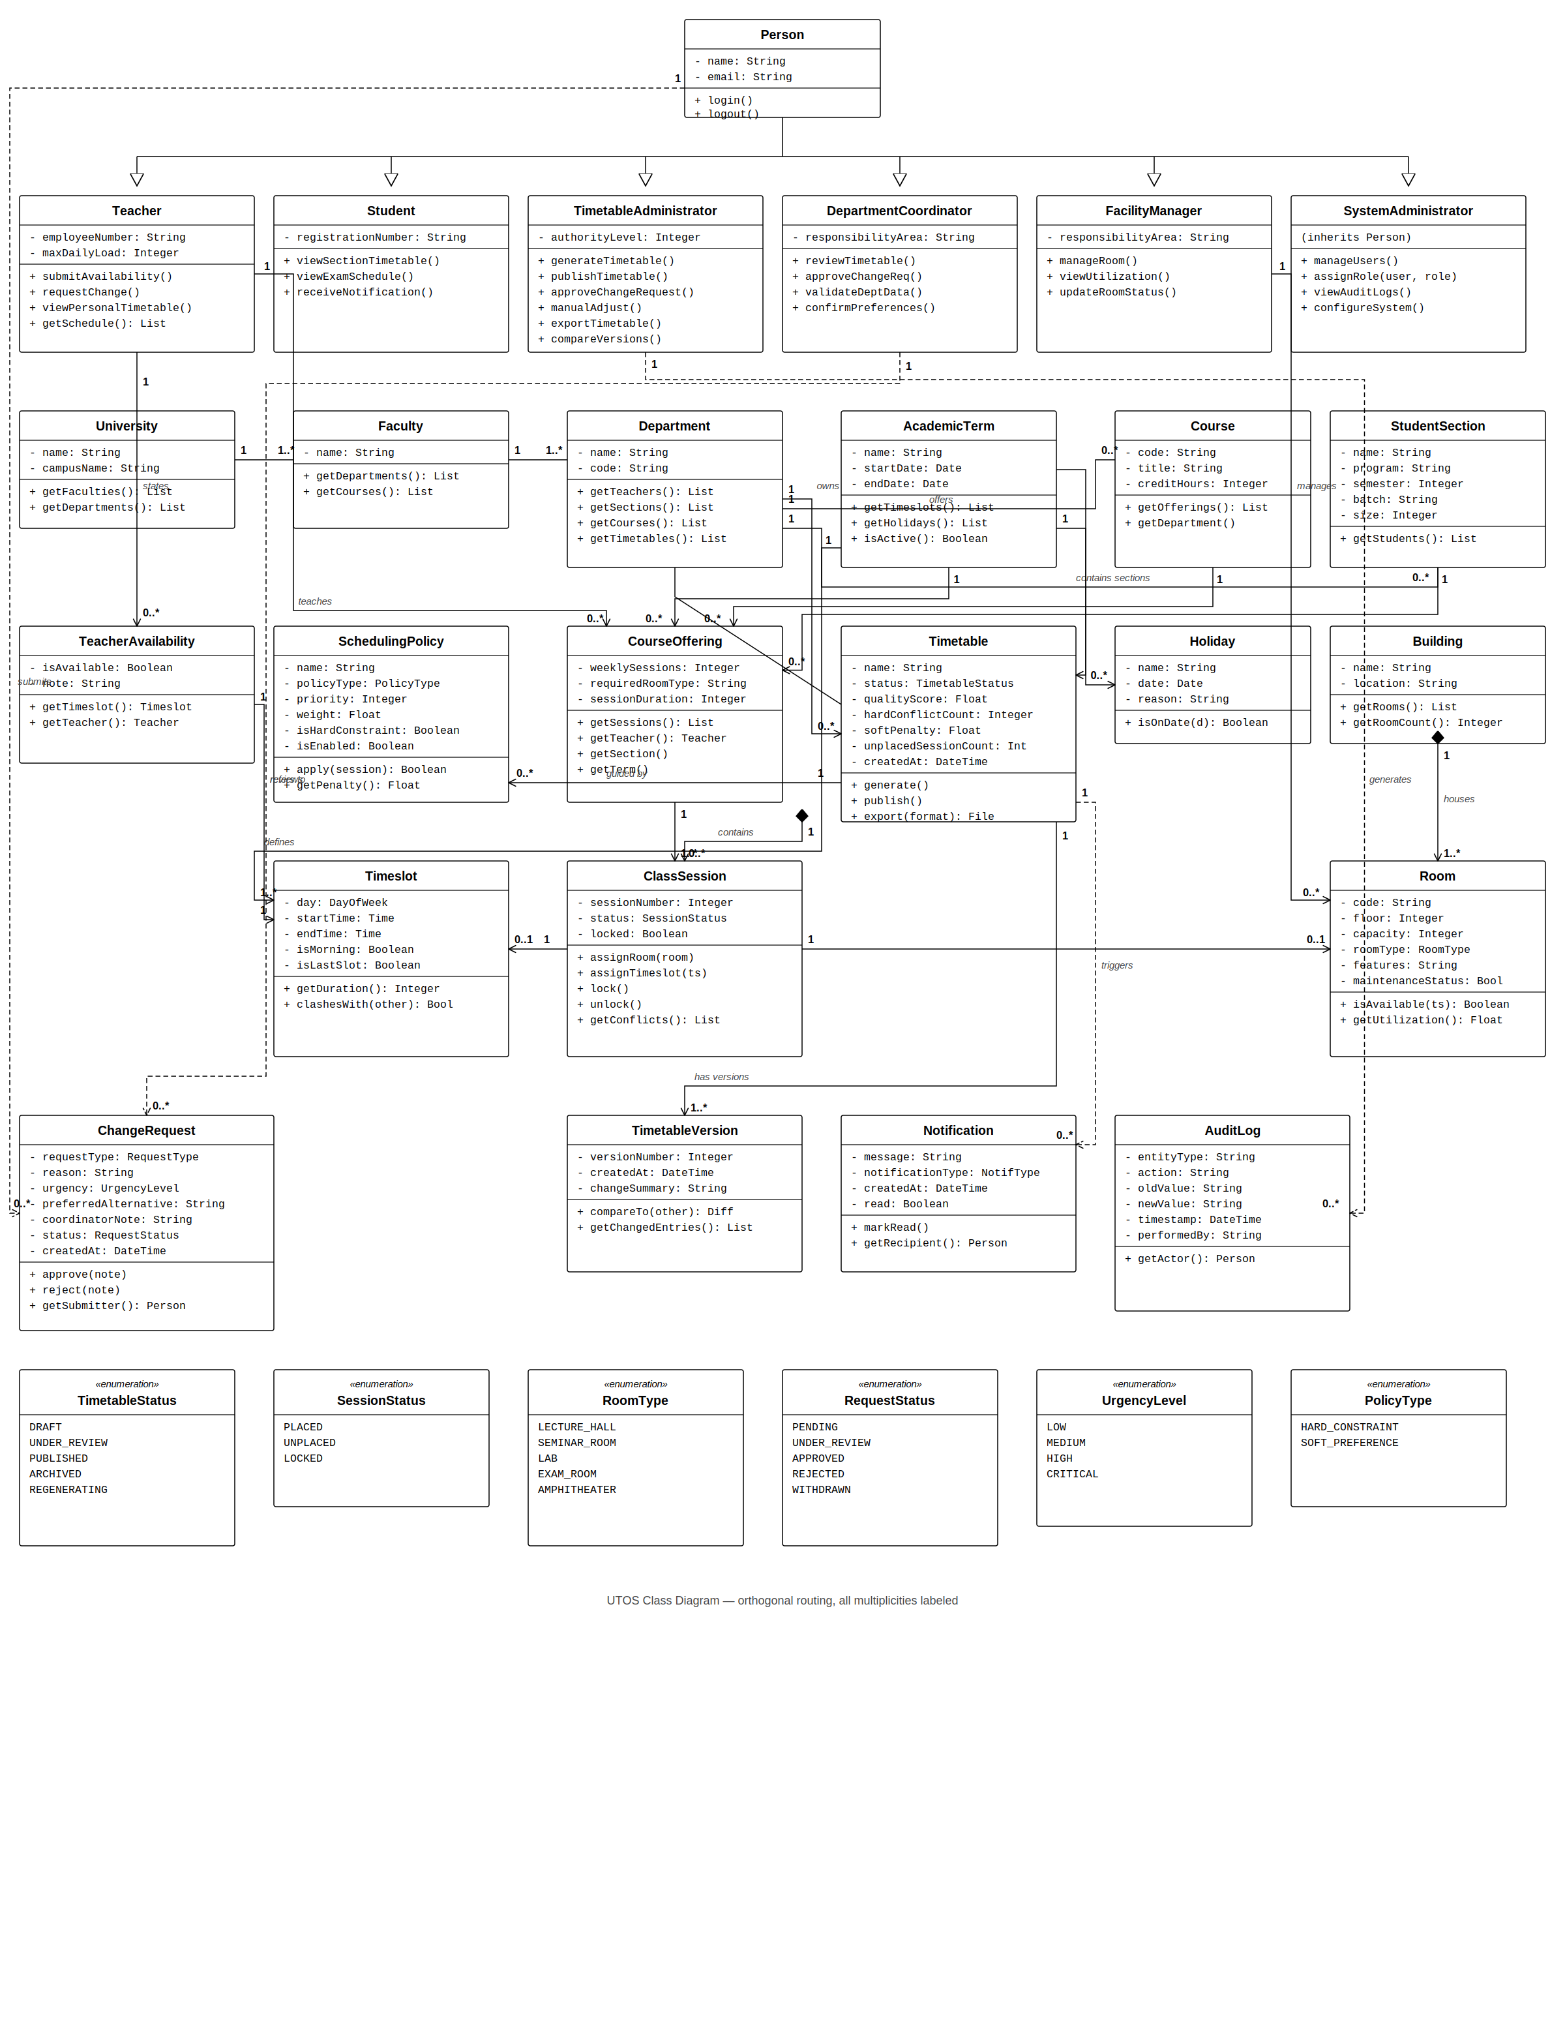
Figure 1. UTOS Class Diagram — orthogonal routing with all multiplicities labelled.

9. Traceability to Use Cases
The table below provides a sample of the traceability between the expanded use cases and the methods in the class diagram. Every use case in UC00–UC22 was checked, and the most representative mappings are listed here.
UC ID | Use Case | Primary Class(es) | Primary Method(s)
UC01 | Login / Authenticate | Person | login(), logout()
UC03 | Submit Teacher Availability | Teacher, TeacherAvailability | submitAvailability()
UC05 | Manage Rooms | FacilityManager, Room | manageRoom(), updateRoomStatus()
UC06 | Configure Scheduling Policy | SchedulingPolicy | apply(), validate()
UC08 | Generate Timetable | Timetable, ClassSession | generate(), assignRoom(), assignTimeslot()
UC09 | Review Timetable Conflicts | Timetable, ClassSession | getConflicts()
UC10 | Manually Adjust Timetable | TimetableAdministrator, ClassSession | manualAdjust(), lock(), unlock()
UC11 | Publish Timetable | Timetable, Notification | publish(), markRead()
UC13 | Submit Change Request | Teacher, ChangeRequest | requestChange()
UC14 | Review / Approve Change Request | DepartmentCoordinator, TimetableAdministrator, ChangeRequest | approve(), reject()
UC15 | Compare Timetable Versions | Timetable, TimetableVersion | compareTo(), getChangedEntries()
UC17 | Export Timetable | TimetableAdministrator, Timetable | export(format)
UC19 | View Personal Timetable | Teacher, Student | viewPersonalTimetable(), viewSectionTimetable()
UC21 | View Audit Logs | SystemAdministrator, AuditLog | viewAuditLogs(), getActor()
UC22 | Manage Users / Assign Role | SystemAdministrator | manageUsers(), assignRole(user, role)

10. Conclusion
The class diagram presented in this document captures the complete static structure of the UTOS at the design layer. Twenty-six domain and system classes, organised into six architectural layers and connected by inheritance, composition, association, and dependency relationships, provide a direct blueprint for implementation.
Every actor responsibility identified in the use cases maps to at least one method; every entity in the domain model maps to a class; every multiplicity from the domain model is preserved on its relationship end; and every cross-cutting concern (auditing, notification, versioning) is modelled as a standalone class so that it can be implemented without polluting the core domain entities.
The diagram is therefore ready to be translated into source code: each class becomes a class declaration, each multiplicity becomes a typed collection or reference, each method becomes an operation signature, and each enumeration becomes a language-level enum or sealed type.

